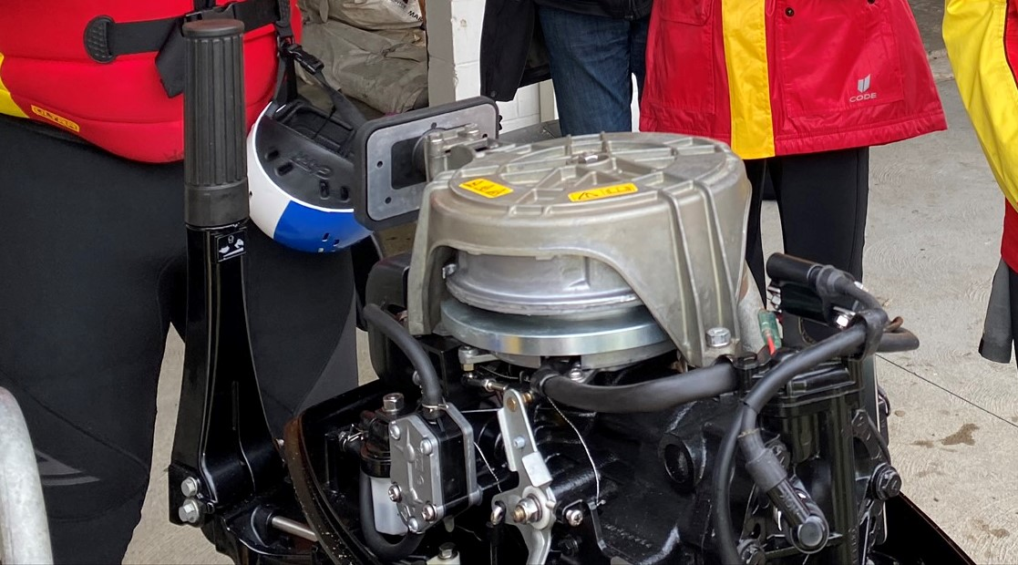
COURSE OVERVIEW
Date: Sunday 4th October 2020
Venue: Ocean Beach Kiwi SLSC
Address: 500 Ocean Beach Rd
Time: 9:30am start – 3:30pm approx. finish
Cost: FREE – candidates are required to bring their own lunch and snacks

MERCURY ENGINE ANNUAL SERVICE WORKSHOP
All IRB engines are required to be serviced annually and a service record for each engine is to be completed and kept by each Club. SLSNZ requires these records must be available for inspection/auditing as required.
This is a FREE opportunity for Clubs to (learn how to) service operational IRB engines in a structured workshop.
A minimum of 1 person (if competent) to work on each engine per workshop is required. Please note there will be more workshops in every area this year to ensure all Clubs have the opportunity to attend.

COURSE INFORMATION
Course Information
Duration: 1 day
Topics covered: Instruction and completion of a full maintenance service on an IRB engine.
Requirements: Tools – bring what you have out of the following;
- 32mm ring spanner (Engine tilt )
- Complete socket set and ratchet
- 10mm & 13mm open ended ring spanners
- 1 large and 1 medium flat screwdrivers
- Large and small Phillips screwdriver
- Medium adjustable crescent

- Long nose pliers
- Flush drum (if you can fit one in)
- Fuel bladder to run engine
- Engine stand/trolley for each engine

Registration: Please register the names of people attending and the number of engines you will bring with (david.hickey@surflifesaving.org.nz) by Sunday 27 September 2020

OUTCOMES
An opportunity for Clubs to service operational IRB engines in a structured workshop.
- Candidates will learn about basic engine maintenance/service requirements.
- Club IRB engines will be “fit for purpose” for the operational season.

PRE-REQUISITES
There are no pre-requisites to attend this workshop.
The people attending for your Club DO NOT need to be lifeguards, an interest in IRB operations is all that is required, so this could be a perfect opportunity to involve parents or Club supporters.
It is also highly recommended that the person responsible for Club engine maintenance attends.

CONTACT

Dave Hickey – National Powercraft Officer
M | 027 280 6420
E E | david.hickey@surflifesaving.org.nz

