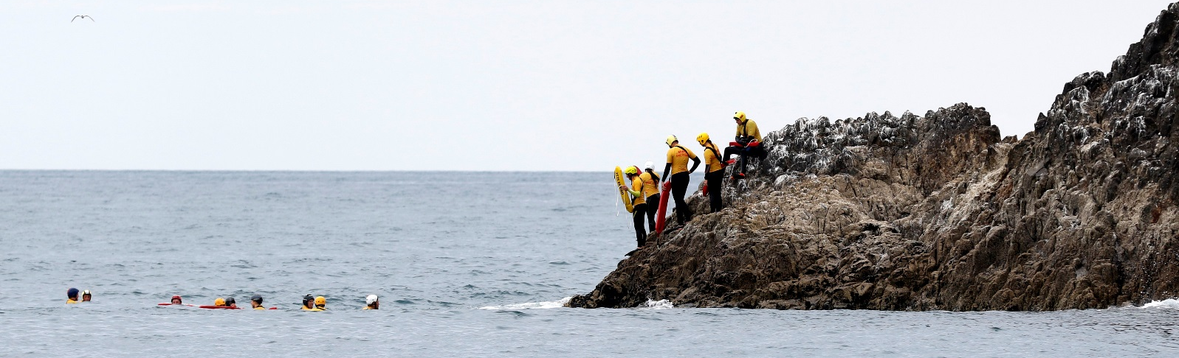

2019 Southern Region Patrol Championships

Date: Saturday 13th April 2019
Venue: Brighton SLSC, Dunedin
Time: 9:30am (Managers Meeting – 9:00am)
Entries close: 5:00pm, Wednesday 10th April 2019

Application Form
Team Name:
Club:
Team Manager’s Name:
Team Manager’s Contact Number:
Team Manager’s Contact Email address:

Team Members
# | Role | Full Name
1 | Driver
2 | Crew
3 | Team Member
4 | Team Member
*Please ensure your team has all the appropriate gear.
- 1 x patrol standard IRB (tube, paddles, knife)
- 1 x petrol bladder + enough fuel for approx. 2 hours of operation
- 4 x PFD / Lifejackets, 4 x Helmets + 4 x High Vis Vests
- 2 x Rescue Tubes (additional to the tube in the teams IRB)
- 1 x Otago capable radio (Out of area clubs will be provided with one)
For more information please contact:
Chris Jeffery | 027 457 1010 | chris.jeffery@surflifesaving.org.nz

