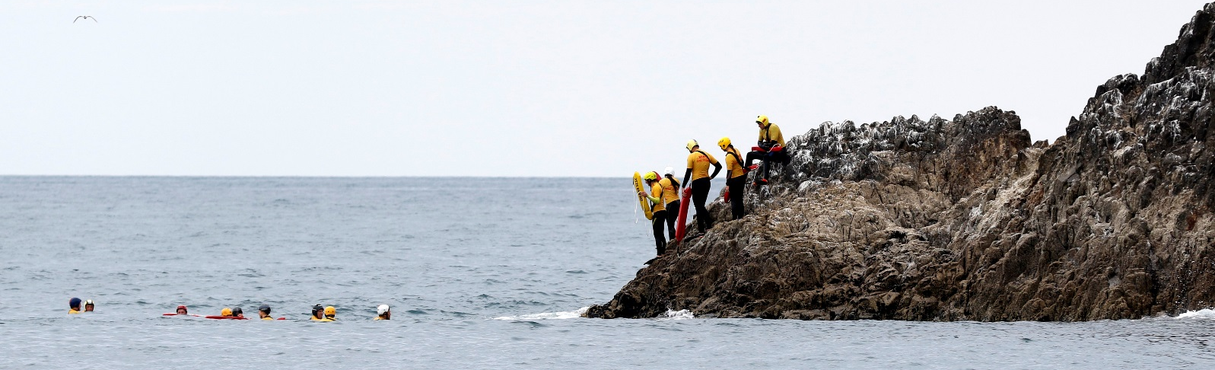

2018 Canterbury Freemasons Rookie Challenge

Date: Sunday 11th March 2018
Venue: Waimairi SLSC
Time: 9am to 11:30am (Managers Meeting – 8:30am)
Entries close: 5:00pm Wednesday 7th March 2018

Application Form

Team Name:
Club or Clubs:
Team Manager’s Name:
Team Manager’s Contact Number:
Team Manager’s Contact Email address:

Team members (Min 3, max 5)

Name |  | Age
Name |  | Age
Name |  | Age
Name |  | Age
Name |  | Age

For more information please contact:
Sam Clutterbuck | 027 457 1010 | sam.clutterbuck@surflifesaving.org.nz

