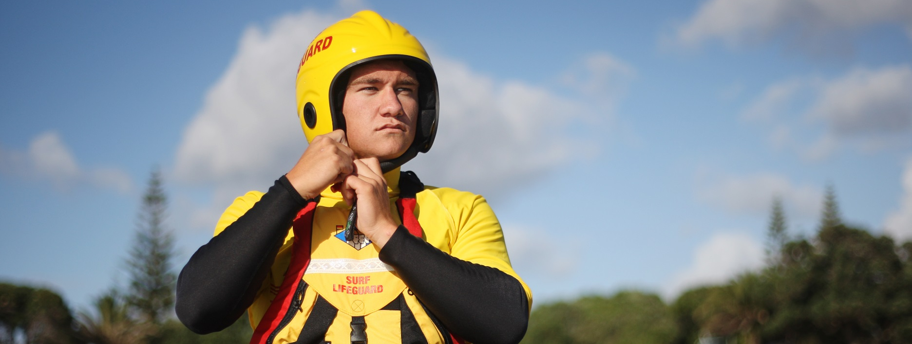
First Aid Level One Course

Date: Mon 15th and Tues 16th January
Venue: Wood Group
Address: 28 Manadon Street, Spotswood
Time: 0830
Cost:
Course Overview:
This is a 2 day resuscitation course covering the following topics: assessment of emergency situations, basic life support, soft tissue injuries, bleeding, shock, fractures and head injuries, hypothermia, asthma, oxygen delivery systems, burns, asthma and basic drowning physiology. Encompasses Unit Standards 6400, 6401 and 6402.
Course Information:
Pre-Requisites: 14 years of age
Current member of a SLS club
Duration: 2 Days
Requirements: Participate in full days of training course
Complete all practical requirements
Complete all theory requirements
Registration: Please contact your club administrator to book this course

Contact: Nova Robinson – Taranaki Club Support Officer
nova.robinson@surflifesaving.org.nz
0275218200

