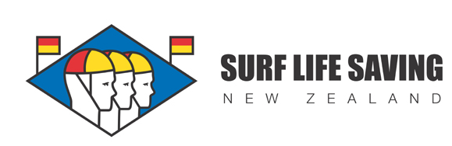
Waimairi Junior Surf Event Sunday 18th January 2015

Managers Meeting 8.30 am
Low Tide: 9:18am High Tide: 3:18pm
ORDER OF EVENTS
9.00 AM START
U14 | Surf Race |  | Board | Diamond | Board Relay | Beach Sprint |  | Beach Relay | Flags
U13 | Surf Race |  | Board | Diamond | Board Relay | Beach Sprint |  | Beach Relay | Flags
U12 | Surf Race |  | Board Relay | Diamond | Board | Flags |  | Beach Relay | Beach Sprint
U11 | Surf Race |  | Board Relay | Diamond | Board | Flags |  | Beach Relay | Beach Sprint
U10 | Board |  | Board Relay | Surf Race | Beach Sprint | Beach Relay |  | Flags | RSR
U9 | Beach Sprint |  | Beach Relay | Flags | Board | Board Relay |  | Run Wade Run | Surf Relay
U8 | Flags |  | Beach Relay | Beach Sprint | Run Wade Run | Surf Relay |  | Board | Board Relay
Relays
Board = 3 per team
Beach Relay = 4 per team (2 x Male, 2 x Female)
Surf Relay = 2 per team
Note: Competitors only go up one age group for team events.

Arenas: |  | Each club will need to provide three people for the following arenas
Water U14/U13 |  | Waimairi
Water U12/U11 |  | Sumner
Board U10/U9/U8 |  | New Brighton |  |  |  |  | Will require 2 persons in the water as buoys for U10/U9/U8 arena
Swim U10/U9/U8 |  | Taylors Mistake |  |  |  |  | Will require 2 persons in the water as buoys for U10/U9/U8 arena
Flags |  | Nth Beach and Waikuku
Sprints |  | Sth Brighton and Spencer Park
*Please note the host club will need to supply 2 lifeguards for the swim arena and an IRB Crew

